Product Upgrade Guide v4.0.5.4

Contents
1 Document Control 3
1.1 Author 3
1.2 Document Summary 3
1.3 Document History 3
1.4 Reference documents 3
1.5 Distribution 3
1.6 Quality Assurance 3
2 Introduction 4
2.1 Purpose 4
2.2 Products Covered by this Guide 4
2.3 Order in which to Upgrade Products 4
2.4 Pre-Requisites to Upgrade 5
3 Network Manager 9
3.1 Installation of the Network Manager Software files 9
3.2 Network Manager Server Upgrade 10
3.2.1 Before you Start 10
3.2.2 Typical problems that you may encounter 10
3.2.3 Upgrade of Network Manager 10
3.2.4 Mandatory Configuration 11
3.2.5 Additional Configuration 12
3.2.6 Spatial Configuration 12
4 Traffic Interface Manager 13
4.1 Implementation of the Traffic Interface Manager Software files 13
4.2 Traffic Interface Manager Server Upgrade 14
4.2.1 Before you Start 14
4.2.2 Typical problems that you may encounter 14
4.2.3 Upgrade of Traffic Interface Manager 14
4.2.4 Mandatory Configuration 15
4.2.5 Additional Configuration 16

- Document Control
  - Author
Exor Development
  - Document Summary
This document covers steps involved in upgrading the components for:
- Network Manager
- Traffic Interface Manager
  - Document History

Document History
Revision | Date | By | Description
1.0 | 31-Mar-2009 | Exor Development | First Edition
2.0 | 28-April-2009 | Exor Development | Second Edition

  - Reference documents
None

  - Distribution
Exor Customers, Partners and Staff

  - Quality Assurance
Document Details
File | Prepared By
0000.doc | Exor Development
Document Name | Reviewed By
Product Upgrade Guide v4.0.5.44 | Colin Stewart
Version | Approved for issue by
2.0 | Colin Stewart
Date of Issue | Support Manager
28-Apr-2009 | Graham Anns

- Introduction
  - Purpose
This guide covers steps involved in upgrading the components for:
- Network Manager
- Traffic Interface Manager

Each product upgrade is split into two distinct stages,

- Stage 1 – Implementation of the Software files
- Stage 2 – Upgrade of the Server

  - Products Covered by this Guide
Table 1 lists the relevant products that are covered by this guide.

Product | Install | Upgrade From 4.0.5.2 | Upgrade From 4.0.5.3
Network Manager | ✗ | ✗ | 
Traffic Interface Manager | ✗ |  | ✗
Table 1: List of products covered by this guide

  - Order in which to Upgrade Products
Table 2 lists the order in which to upgrade the products in this release.

Product to Upgrade/(Install) | Order to Upgrade
Network Manager | 1
Traffic Interface Manager | 2
Table 2: Order in which to upgrade products

  - Pre-Requisites to Upgrade
It is assumed that the audience of this document understand the configuration of the servers being upgraded and are sufficiently proficient with SQL*Plus. It is also assumed that the terminology used in this document is understood by the reader.

NB. The instructions for installation of the software describes the installation of all the software into a single area (usually referred to as the ‘Client’). The instructions for upgrading the Server (your Highways schema) assume you have access to the database from the ‘Client’.

Your configuration and server access may differ from this; the InstallShield can still be used for installation. For example, you may have to install the Client software on the Application Server and the Server software on the Database Server for reasons of database access availablilty from the Application Server.

If in any doubt please contact support@exorcorp.com.

Before attempting to upgrade, you should ensure that;

- the appropriate software components are installed and are compatible with the exor certification matrix. The certification matrix can be downloaded from the Client area of the exor website.

- all users are disconnected from the system

- the highways listener processes are not running

- a database export of the owner of Highways owner has been taken.

- You MUST copy the current <exor_base> directory and sub-directory structure and contents to a new area (e.g. <exor_base4050>). This ensures that a copy is available for backup or reference purposes should any issues arise during the installation.
The installation can then continue into a new area (e.g. <exor_install4051>) which should then be copied onto the <exor_base>.

For Example:
….copy the current <exor_base> directory and sub-directory structure and contents to a new area (e.g. <exor_base4050>)

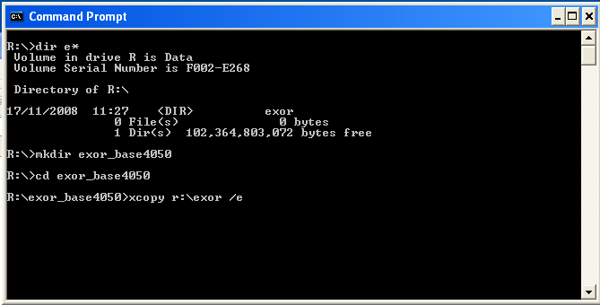

… The installation can then continue into a new area (e.g. <exor_install4051>)

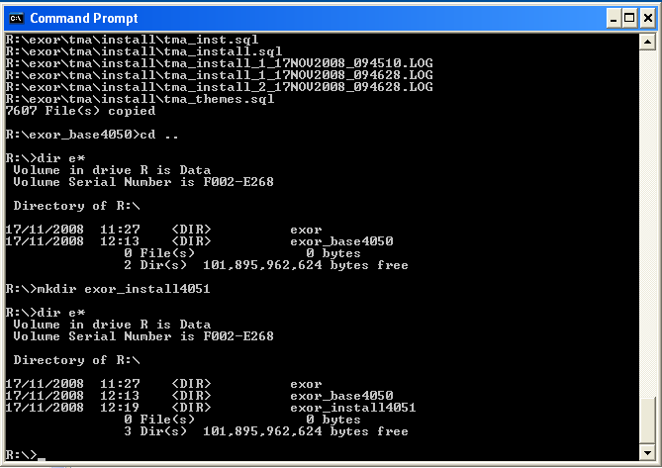

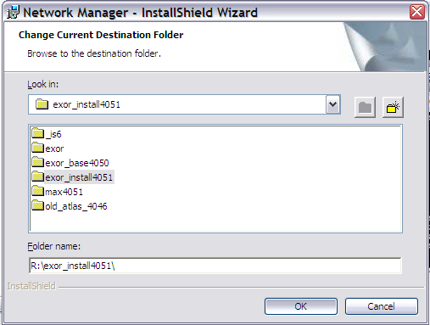

… which should then be copied onto the <exor_base>

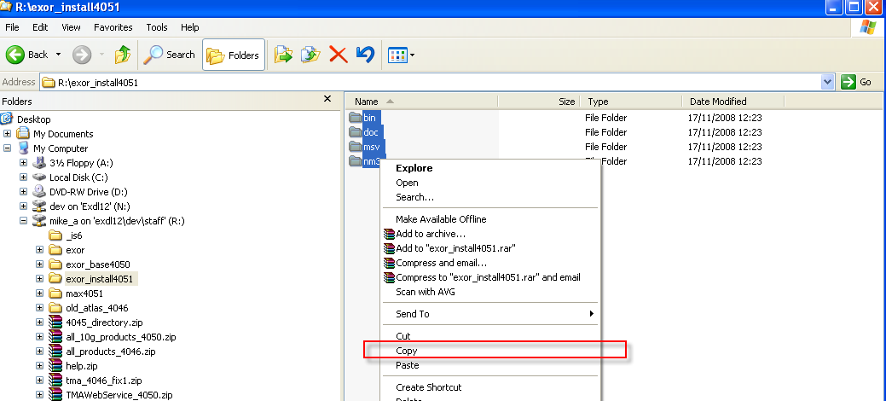

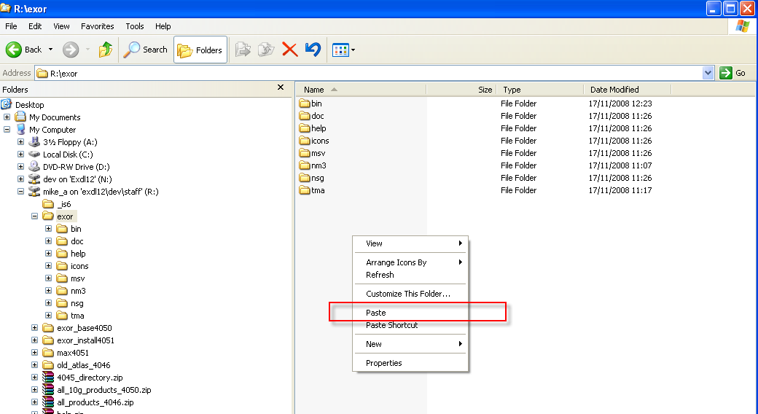

- Network Manager
  - Installation of the Network Manager Software files
To install the software components for Network Manager execute the setup_network_manager_4054.exe and follow the on-screen prompts.

Extremely Important:

This is a patch release to be installed on top of release 4.0.5.3

It is crucial that when selecting the ‘Destination Folder’, you select that directory under which the existing 4.0.5.3 software resides.

When the wizard completes, the necessary client and server software files will have been installed.

Notes:
A password is required to be entered during this process. If you are not sure of the password contact support@exorcorp.com.

  - Network Manager Server Upgrade
This chapter provides details of steps involved in upgrading the server components for Network Manager.

Important:
This product will require upgrading before any other 4.0.5.4 product upgrades.

    - Before you Start

Before proceeding please ensure that the pre-requisites mentioned in Section 2.3 of this document are met.

Also, please be aware of the following;

Where instructed to change to a directory before running a script, it is assumed that you are running SQL*PLUS from a DOS Command prompt.

If you are running SQL*PLUS in windows you should set the 'start in' directory of the SQL*PLUS shortcut to simulate the change of directory.

If you do not run SQL*PLUS from the directory stated in each step of the guide, the installation will fail.

Also, whilst following the instructions in this section you will be required to know the location of <exor_base>. You may recall that whilst undertaking the tasks in Section 3.1 you will have implemented software into the location referred to as <exor_base>, for example, C:\EXOR.

    - Typical problems that you may encounter

It is possible that, when you are running some of the upgrade scripts, errors may be reported saying that objects already exist in the database or that columns already exist on tables. These errors can generally be ignored. If you are in any doubt, please contact the Exor support desk for guidance.

The upgrade procedures will also attempt to install database roles in the highways owner account that are necessary for the system to operate correctly. You may find that errors are produced when running the upgrade scripts to the effect that the role names being created are already used by existing roles or users. These errors can be ignored as they simply mean that the roles being created already exist.

Also during upgrade Warning messages may appear saying that compilation errors have occurred. These warnings can be ignored, since invalid objects will be recompiled prompt later on in the upgrade. However it will be of concern if compilation errors still occur following the re-compilation.

    - Upgrade of Network Manager

This section describes the steps necessary to upgrade Network Manager to 4.0.5.4

Important
The server upgrade relies on invoking scripts shipped with the previous release. Therefore it is essential that the software was installed into the correct destination folder, as instructed in the previous chapter.

To upgrade the base data and objects for the Network Manager modules;

- Change directory to <exor_base>\nm3\install

- Login to SQL*PLUS as the highways owner on the client PC

- Run the following command
start nm4053_nm4054.sql

- You will be prompted to enter the path of the location of your highways software. This should be name of the directory, including disk identifier and a trailing slash character, referred to as <exor_base>.

For example, if you installed your highways software in a directory called EXOR on your C drive, you would enter the following when prompted.

C:\EXOR\

- When you have supplied this value, you will be prompted to confirm that it is correct and asked whether you wish to continue.

- If the value specified is not correct or does not end with a slash character, you will be given an error message and the installation script will abort. You will then need to login to SQL*PLUS again and rerun the script.

- When the script has completed, all the Network Manager objects and data will have been upgraded.

Checking Log File(s)

The following log files are produced in the working directory. At the end of the upgrade, they can be viewed to check for any errors that could have occurred during the upgrade process.

nm4053_nm4054_1_<date&time>.LOG
nm4053_nm4054_2_<date&time>.LOG

Log files should be emailed to support@exorcorp.com to allow exor support staff to verify the upgrade has been successful.

Due to interdependencies between some Exor products, please ignore all compilation errors until all of your products have been upgraded.

    - Mandatory Configuration

exor_version.txt

Before accessing Network Manager you must check the file exor_version.txt.

This file is referenced in Windows Registry setting ‘EXOR_VERSION’ and by default can be located in the <exor_base>\bin directory.

Ensure that the entry for Network Manager is set accordingly;

NET=4.0.5.4
HIG=4.0.5.4
AST=4.0.5.4
DOC=4.0.5.4
WMP=4.0.5.4

    - Additional Configuration

Consult the documentation that accompanies this release for details of any additional configuration that may be required following an upgrade.

For example, to obtain details of product options, and for details of new product features/amendments.

Important:
It is highly recommended that you do this before attempting to use the application.

    - Spatial Configuration

Specific information regarding the registration of spatial layers can be found in the “Locator and Web Mapping” document.

- Traffic Interface Manager
  - Implementation of the Traffic Interface Manager Software files

To install the software components for Traffic Interface Manager execute the setup_traffic_interface_manager_4054.exe and follow the on-screen prompts.

When the wizard completes, the necessary client and server software files will have been installed.

Notes:
A password is required to be entered during this process. If you are not sure of the password contact support@exorcorp.com.

Important:
All exor applications that you install must go into the same destination – what is often referred to as <exor_base>.

To support different roll-out models, you can decide to just install Client or Server or both sets of components into the <exor_base>.

  - Traffic Interface Manager Server Upgrade
This chapter provides details of steps involved in upgrading the server components for Traffic Interface Manager.

Important:
This product will require upgrading after Network Manager.

    - Before you Start

Before proceeding please ensure that the pre-requisites mentioned in Section 2.3 of this document are met.

Also, please be aware of the following;

Where instructed to change to a directory before running a script, it is assumed that you are running SQL*PLUS from a DOS Command prompt.

If you are running SQL*PLUS in windows you should set the 'start in' directory of the SQL*PLUS shortcut to simulate the change of directory.

If you do not run SQL*PLUS from the directory stated in each step of the guide, the installation will fail.

Also, whilst following the instructions in this section you will be required to know the location of <exor_base>. You may recall that whilst undertaking the tasks in Section 4.1 you will have implemented software into the location referred to as <exor_base>, for example, C:\EXOR.

    - Typical problems that you may encounter

It is possible that, when you are running some of the upgrade scripts, errors may be reported saying that objects already exist in the database or that columns already exist on tables. These errors can generally be ignored. If you are in any doubt, please contact the Exor support desk for guidance.

The upgrade procedures will also attempt to install database roles in the highways owner account that are necessary for the system to operate correctly. You may find that errors are produced when running the upgrade scripts to the effect that the role names being created are already used by existing roles or users. These errors can be ignored as they simply mean that the roles being created already exist.

Also during upgrade Warning messages may appear saying that compilation errors have occurred. These warnings can be ignored, since invalid objects will be recompiled prompt later on in the upgrade. However it will be of concern if compilation errors still occur following the re-compilation.

    - Upgrade of Traffic Interface Manager

This section describes the steps necessary to upgrade Traffic Interface Manager to 4.0.5.4

Important
The server upgrade relies on invoking scripts shipped with the previous release. Therefore it is essential that the software was installed into the correct destination folder, as instructed in the previous chapter.

To upgrade the base data and objects for the Traffic Interface Manager modules;

- Change directory to <exor_base>\tm3\install

- Login to SQL*PLUS as the highways owner on the client PC

- The same script is used to upgrade from the previous version shown in Section 2.2.
Run the following command

start tm40_tm4054.sql

- You will be prompted to enter the path of the location of your highways software. This should be name of the directory, including disk identifier and a trailing slash character, referred to as <exor_base>.

For example, if you installed your highways software in a directory called EXOR on your C drive, you would enter the following when prompted.

C:\EXOR\

- When you have supplied this value, you will be prompted to confirm that it is correct and asked whether you wish to continue.

- If the value specified is not correct or does not end with a slash character, you will be given an error message and the installation script will abort. You will then need to login to SQL*PLUS again and rerun the script.

- When the script has completed, all the Traffic Interface Manager objects and data will have been upgraded.

Checking Log File(s)

The following log files are produced in the working directory. At the end of the upgrade, they can be viewed to check for any errors that could have occurred during the upgrade process.

tm40_tm4054_1_<date&time>.LOG
tm40_tm4054_2_<date&time>.LOG

Log files should be emailed to support@exorcorp.com to allow exor support staff to verify the upgrade has been successful.

Due to interdependencies between some Exor products, please ignore all compilation errors until all of your products have been upgraded.

    - Mandatory Configuration

exor_version.txt

Before accessing Traffic Interface Manager you must check the file exor_version.txt.

This file is referenced in Windows Registry setting ‘EXOR_VERSION’ and by default can be located in the <exor_base>\bin directory.

Ensure that the entry for Traffic Interface Manager is set accordingly;

TM=4.0.5.4

    - Additional Configuration

Consult the documentation that accompanies this release for details of any additional configuration that may be required following an upgrade.

For example, to obtain details of product options, and for details of new product features/amendments.

Important:
It is highly recommended that you do this before attempting to use the application.

